# ConsciousBudget Application UI Mock-ups

## Executive Summary

This document presents comprehensive UI mock-up variants for the ConsciousBudget personal finance management application. Based on the detailed software requirements specification, I have created 3 variants each for all major application screens across both mobile and web platforms. The designs emphasize a dark mode, minimalist aesthetic with sample data integration, following modern financial application UI patterns while prioritizing the expense entry form as the primary landing screen.

The mock-ups incorporate essential widgets including expense summary dashboards, hierarchical category management, budget tracking with progress indicators, and comprehensive reporting with time-filtered analytics. Each variant explores different layout approaches while maintaining consistency with the application's core principles of simplicity, privacy, and user-centric design.

## Mobile Application Mock-ups

## Expense Entry Forms (Primary Landing Screen)

The expense entry form serves as the main entry point for the mobile application, designed for quick and intuitive expense logging with minimal user interaction.

Variant 1: Traditional Form Layout  
This variant presents a clean, vertical form structure with clearly labeled input fields for amount, category selection, and date picker. The design emphasizes large touch targets and clear visual hierarchy.

Untitled 1

Mobile expense entry form - Dark mode minimalist design variant 1

Variant 2: Numeric Keypad Focus  
The second variant features an integrated numeric keypad for rapid amount entry, with category selection through icon-based buttons and streamlined date input.

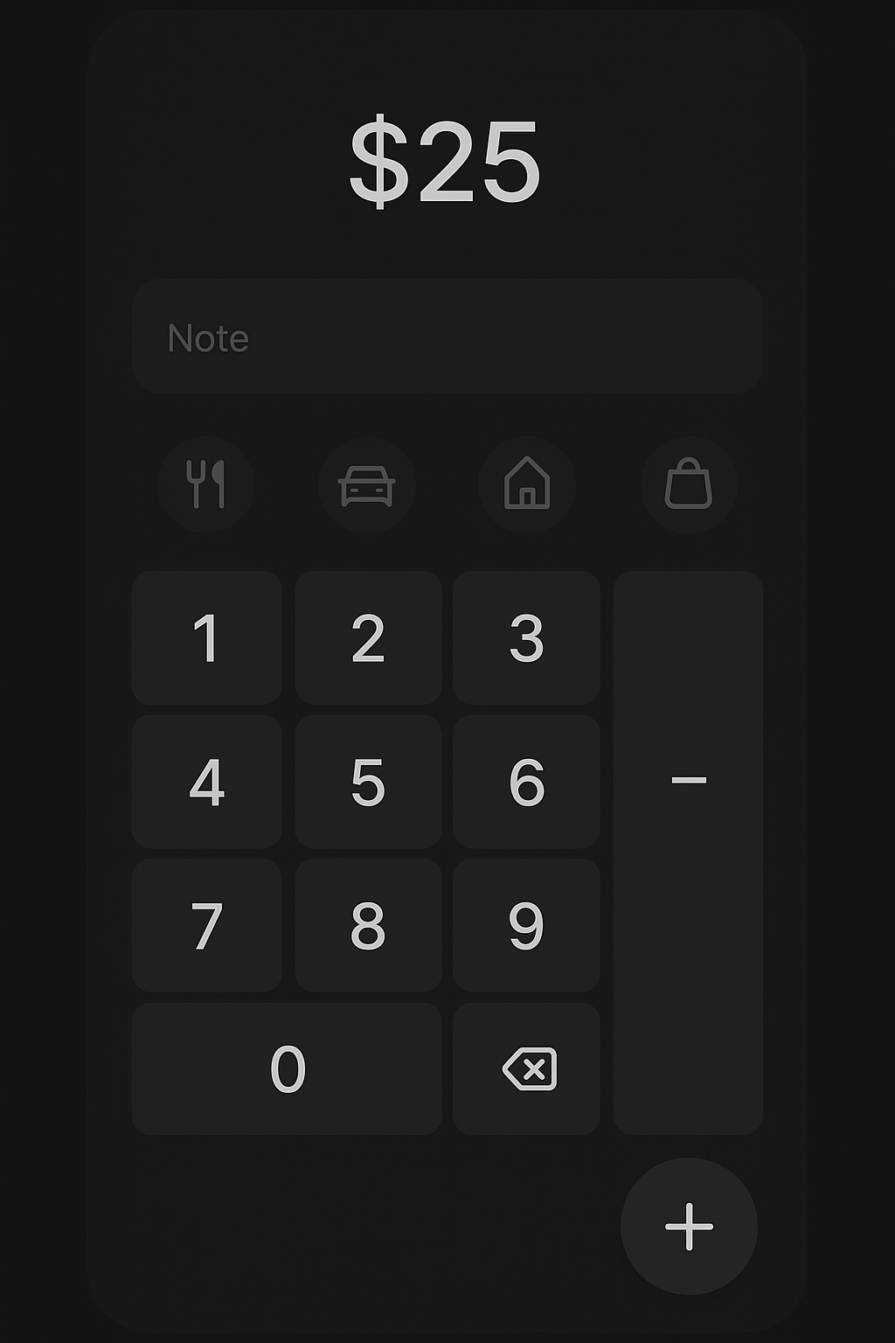

Mobile expense entry form - Dark mode minimalist design variant 2

Variant 3: Card-Based Interface  
This variant uses a card-based design with category pills and floating action elements, providing a modern approach to expense entry with enhanced visual appeal.

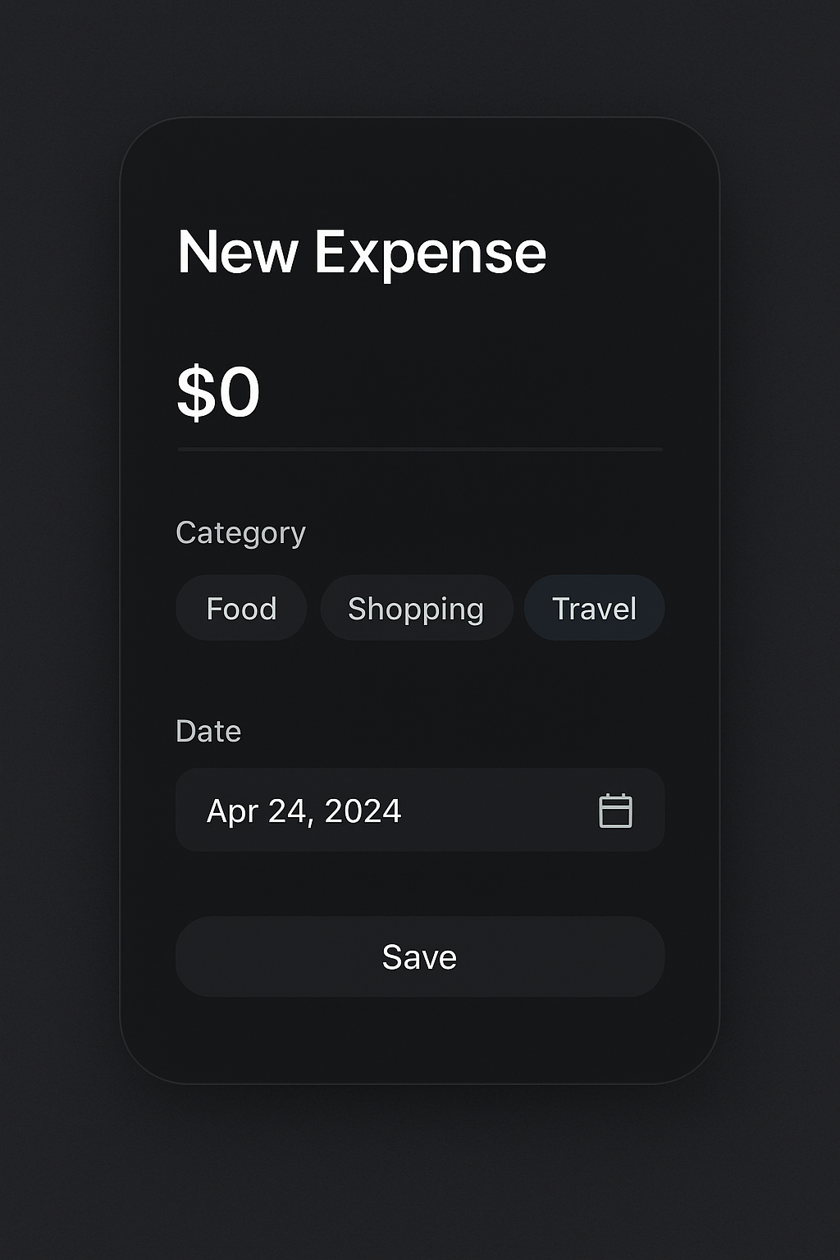

Mobile expense entry form - Dark mode minimalist design variant 3

## Home Dashboard with Expense Summary

The dashboard provides users with comprehensive financial overview including balance display, spending categorization, and visual analytics.

Variant 1: Comprehensive Overview  
Features a complete financial summary with pie chart visualization, monthly budget progress bars, and recent transaction listings in a dark theme.

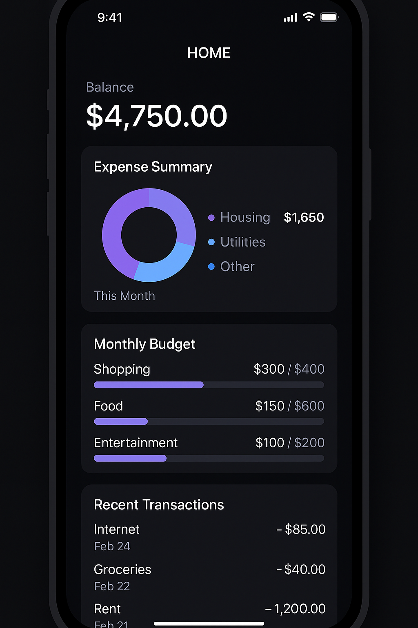

Mobile home dashboard - Dark mode expense summary variant 1

Variant 2: Category-Focused Design  
Emphasizes spending categories through card-based layout with individual category breakdowns, time filter controls, and bar chart analytics.

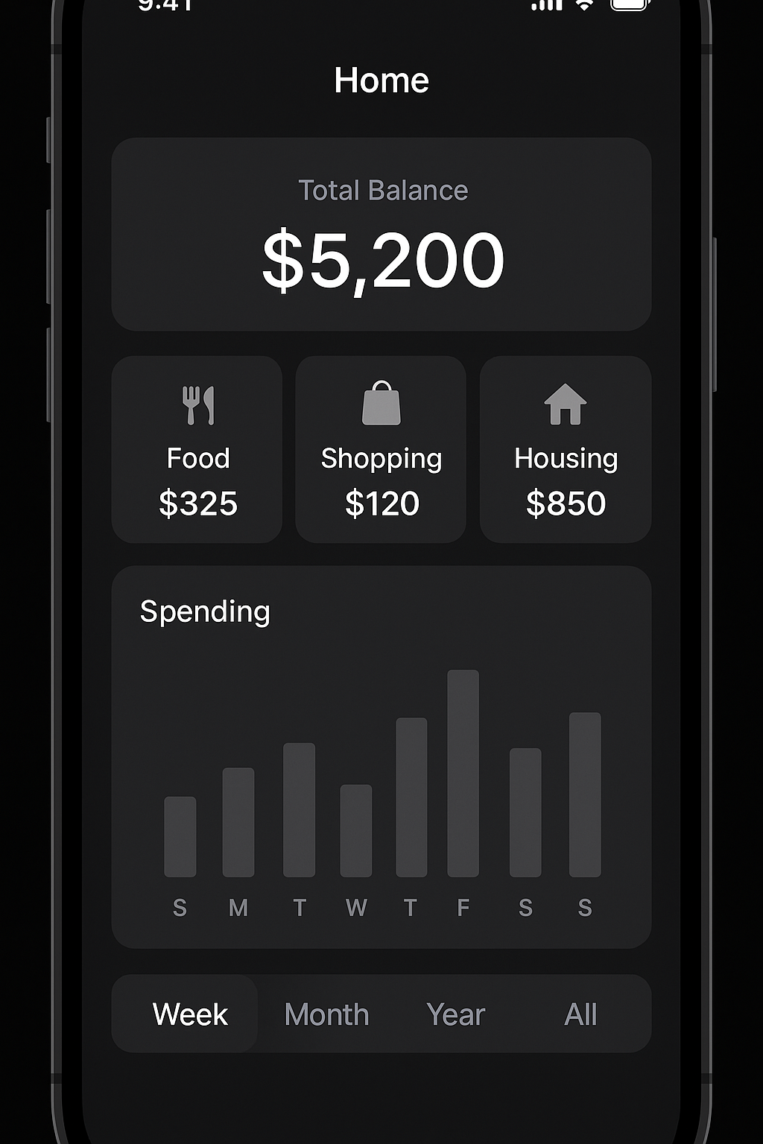

Mobile home dashboard - Dark mode expense summary variant 2

Variant 3: Minimal Analytics  
Presents a clean, minimal approach with donut chart visualization, category grid layout, and prominent quick action buttons.

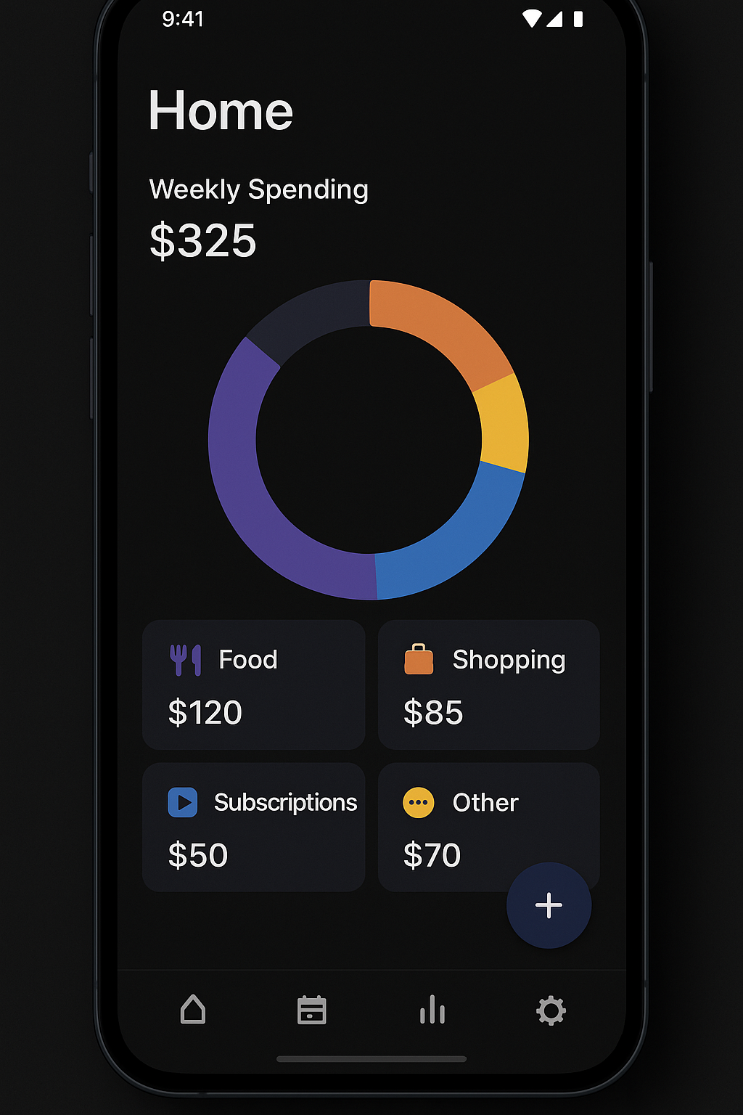

Mobile home dashboard - Dark mode expense summary variant 3

## Category Management

The category management system supports the application's hierarchical categorization requirements, including the ability to create multiple instances of categories (e.g., Housing - Main House, Housing - Vacation Home).

Variant 1: Hierarchical List View  
Displays categories in an expandable tree structure, allowing users to navigate through parent and child categories with clear visual indicators.

Mobile category management - Dark mode hierarchical categories variant 1

Variant 2: Icon Grid Layout  
Presents categories as an organized grid with descriptive icons, enabling quick selection and visual category identification.

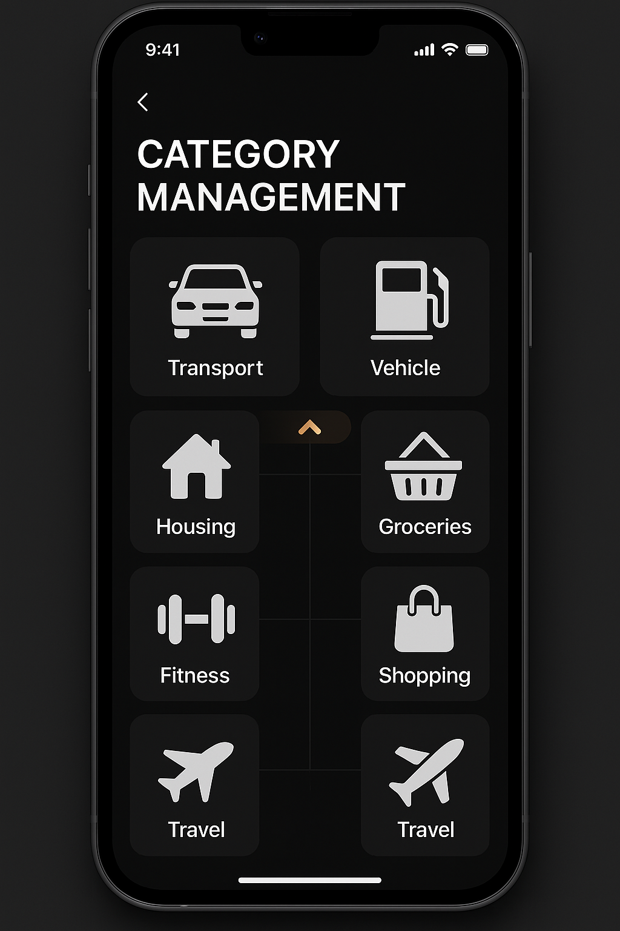

Mobile category management - Dark mode grid layout variant 2

Variant 3: Searchable Categories  
Incorporates search functionality with card-based category display, edit/delete options, and streamlined category management tools.

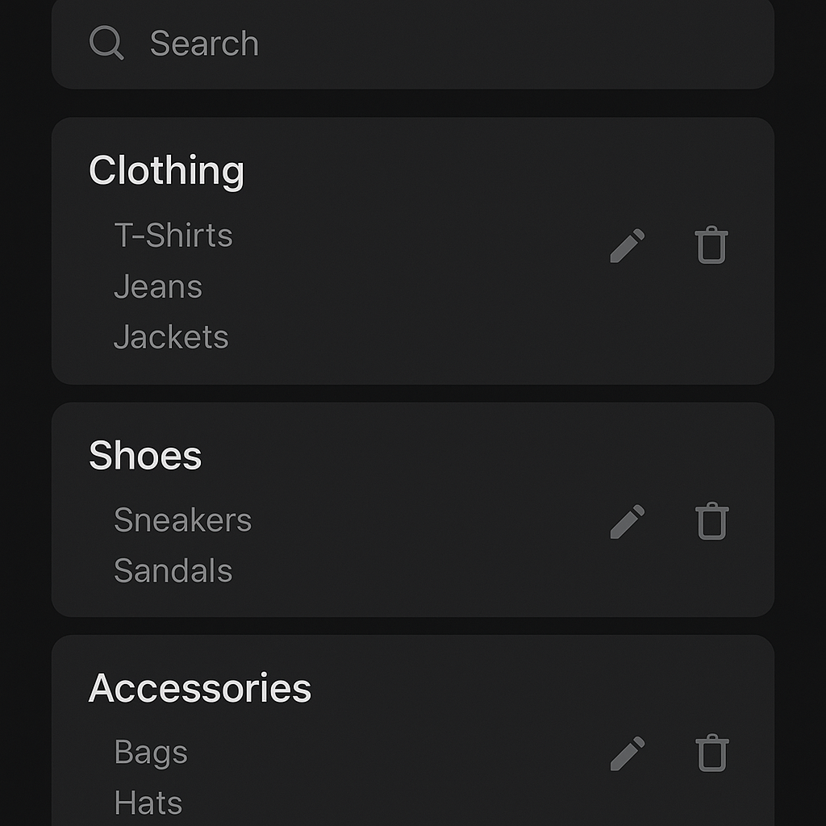

Mobile category management - Dark mode searchable categories variant 3

## Budget Tracking and Reports

The budget tracking interface provides comprehensive spending analysis with multiple visualization options and time-based filtering.

Variant 1: Progress Tracking Focus  
Centers on circular progress indicators showing budget vs. actual spending with category-specific breakdowns and alert notifications.

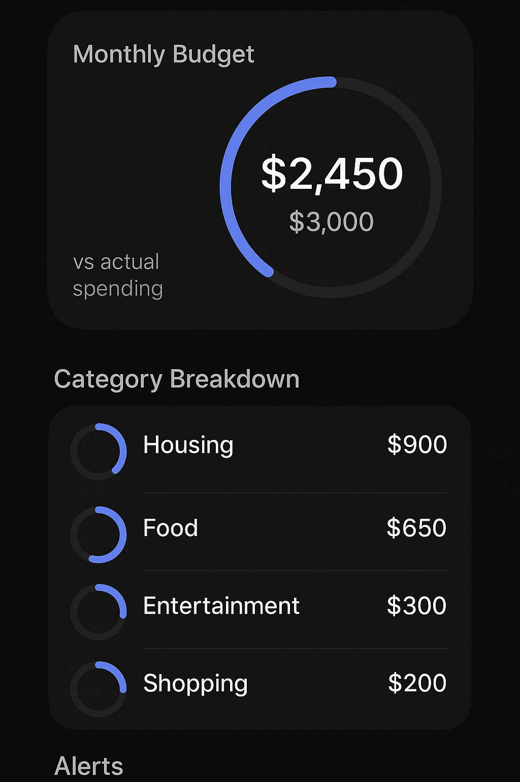

Mobile budget tracking - Dark mode progress tracking variant 1

Variant 2: Analytics and Trends  
Emphasizes data visualization through line charts, spending trend analysis, and comparative reporting with multiple time filter options.

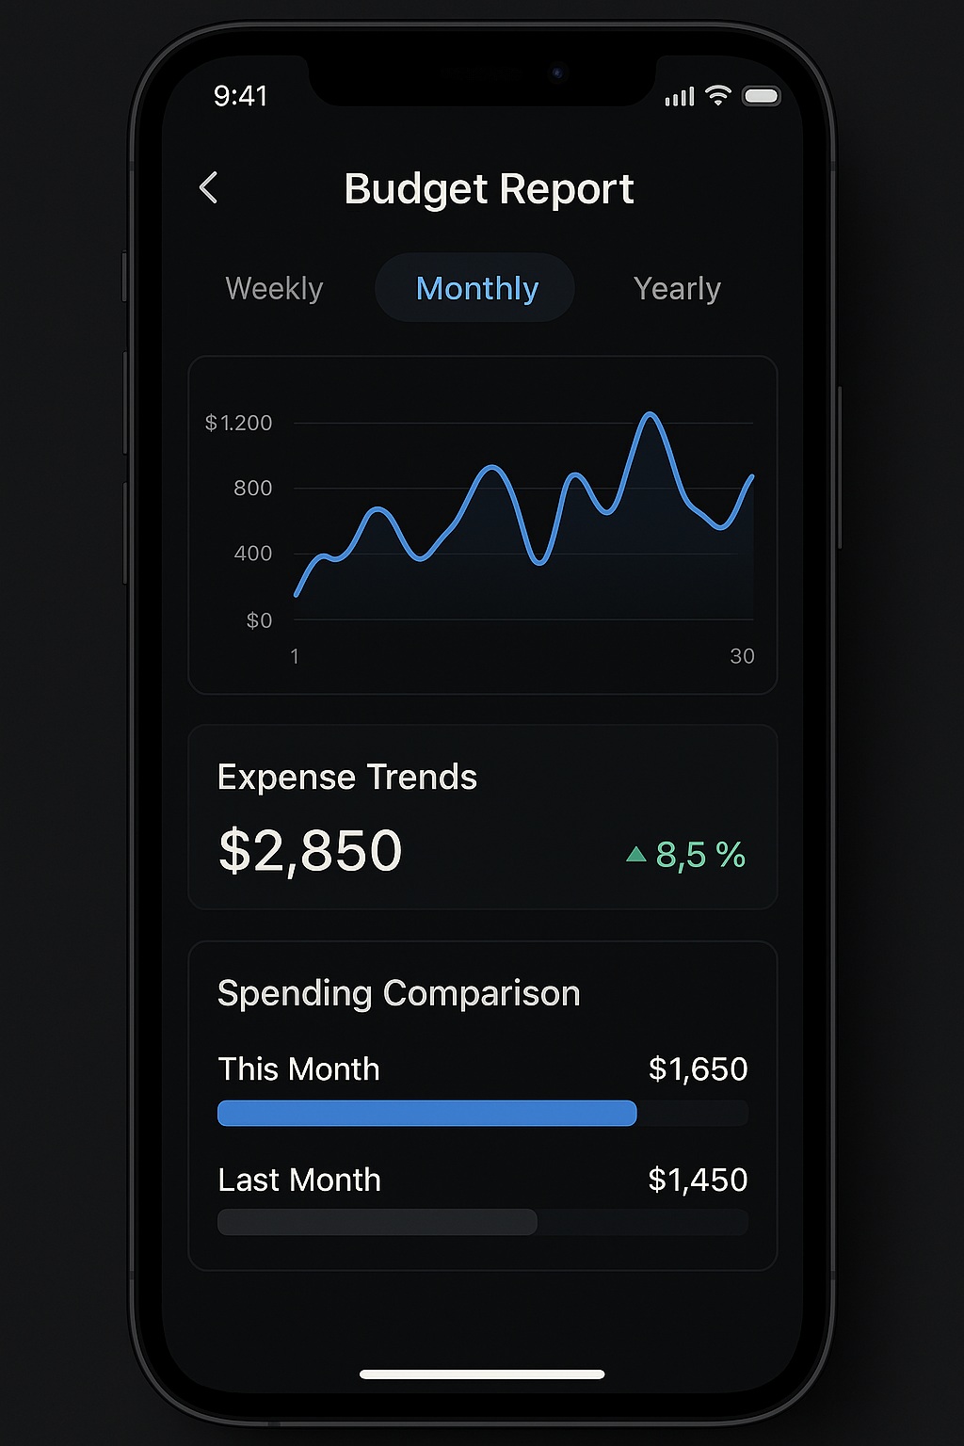

Mobile budget tracking - Dark mode reports and analytics variant 2

Variant 3: Financial Overview  
Provides a comprehensive financial summary with savings goals, category breakdowns, and progress tracking in an integrated dashboard view.

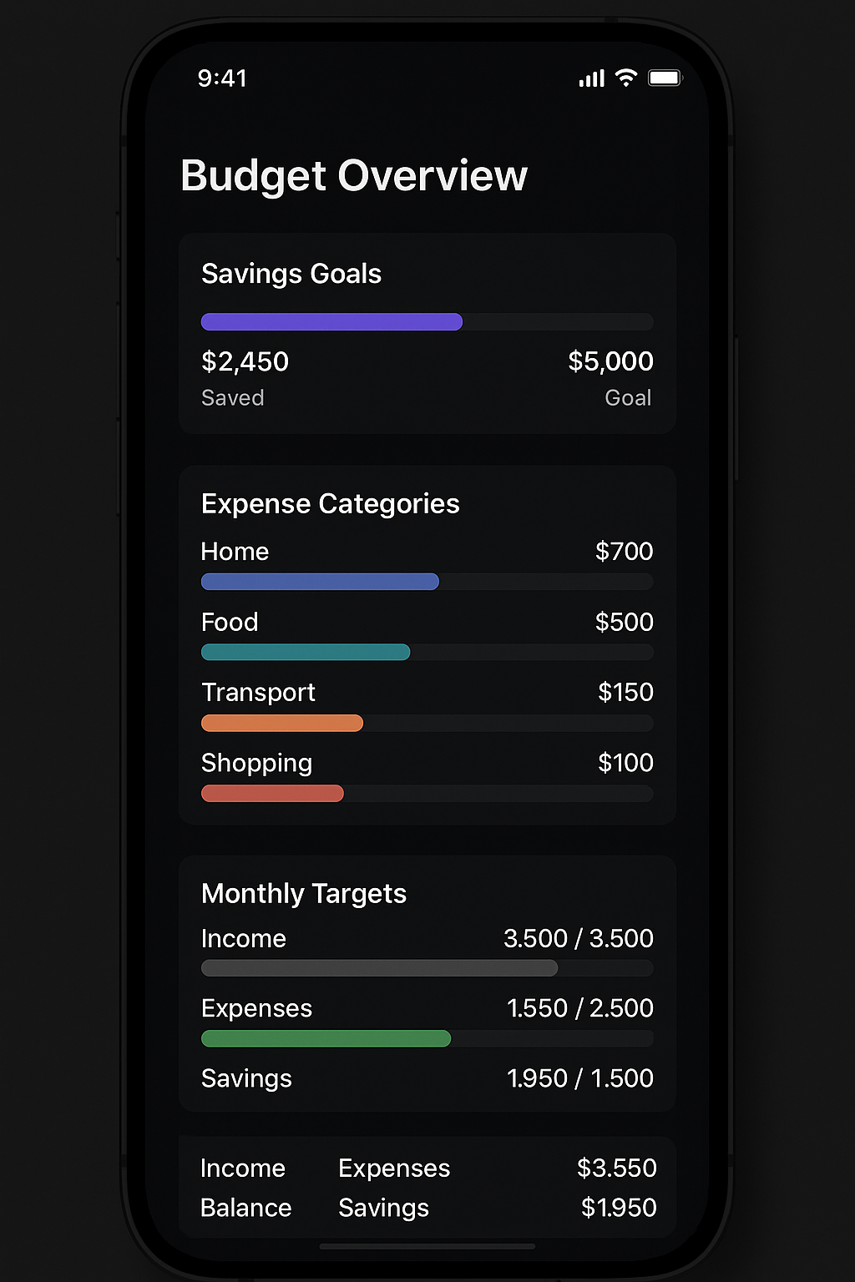

Mobile budget tracking - Dark mode financial overview variant 3

## Web Application Mock-ups

## Expense Entry Forms (Primary Landing Screen)

The web application expense entry forms are optimized for desktop use while maintaining the same core functionality as the mobile version.

Variant 1: Sidebar Navigation Layout  
Features a traditional desktop layout with sidebar navigation, large input fields, and comprehensive form controls optimized for keyboard and mouse interaction.

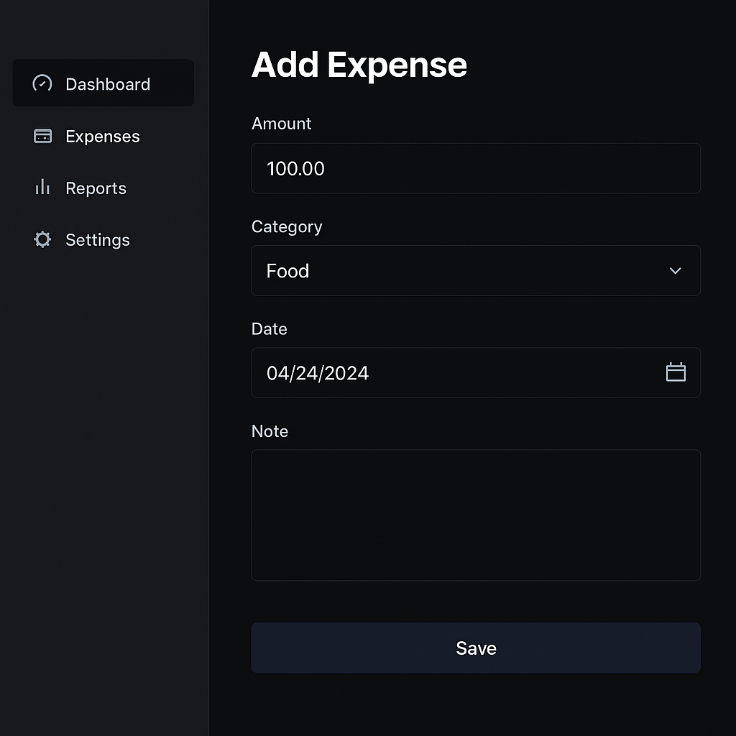

Web app expense entry form - Dark mode desktop layout variant 1

Variant 2: Modal Popup Interface  
Presents the expense entry form as a centered modal popup, providing focused interaction while maintaining access to background dashboard information.

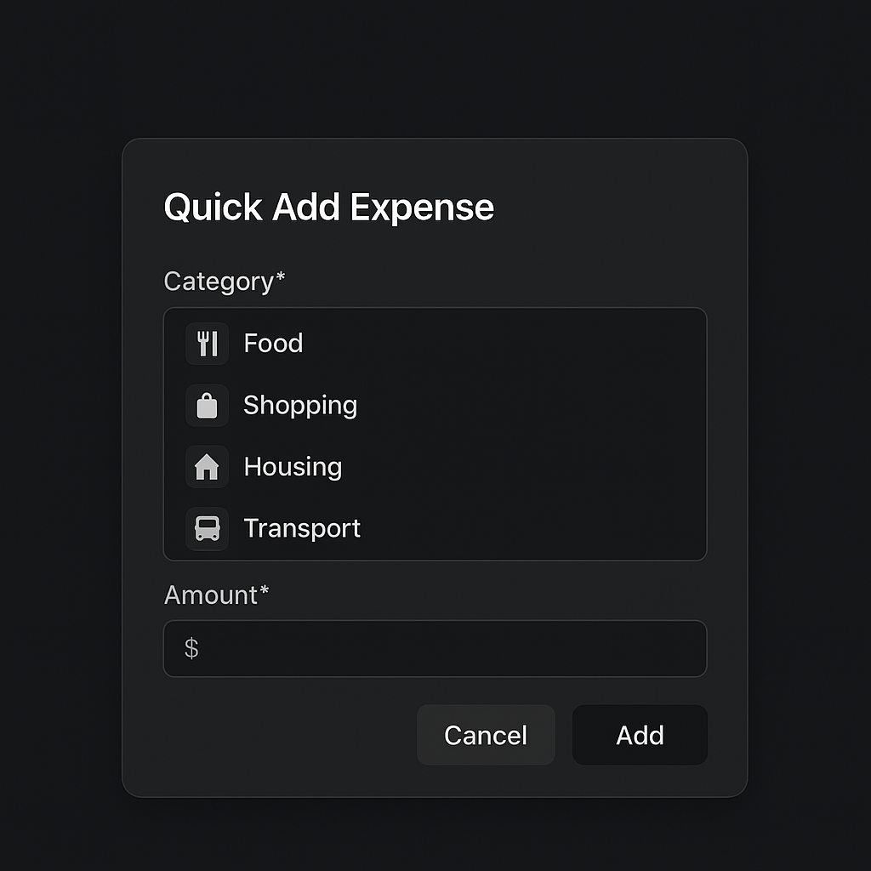

Web app expense entry form - Dark mode modal popup variant 2

Variant 3: Split Screen Design  
Utilizes a split-screen approach with the entry form on the left and recent transactions or category suggestions on the right, maximizing screen real estate.

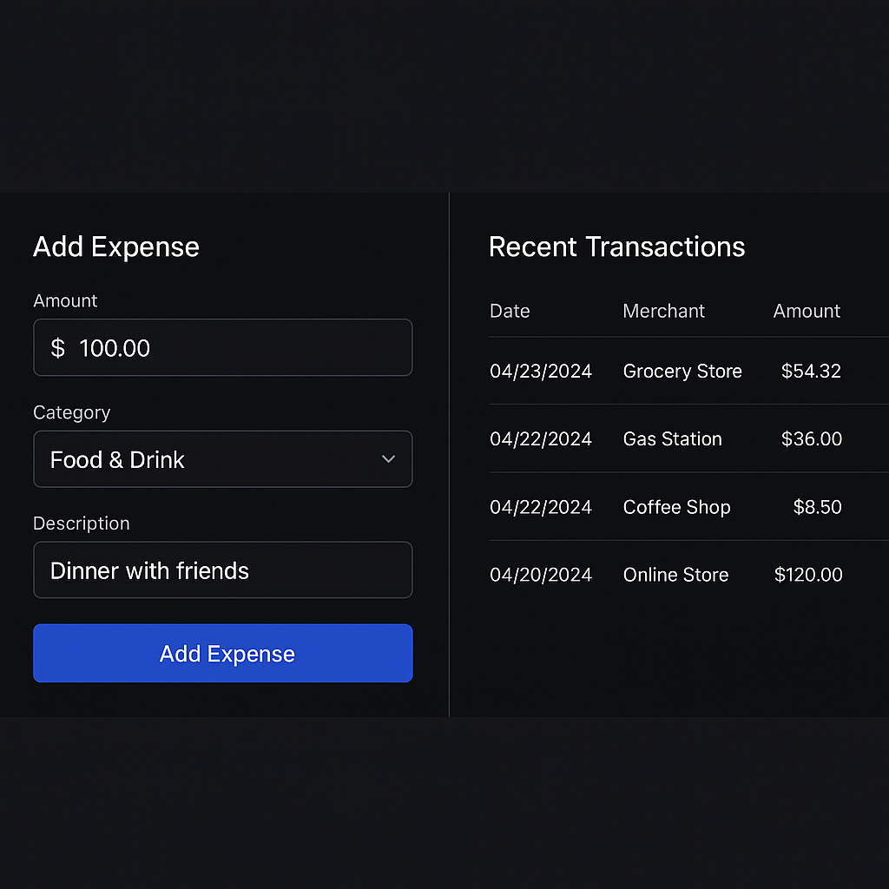

Web app expense entry form - Dark mode split screen variant 3

## Home Dashboard with Expense Summary

The web dashboard leverages the larger screen space to provide comprehensive financial analytics and multiple data visualization options.

Variant 1: Comprehensive Dashboard  
Incorporates sidebar navigation with extensive expense summary cards, pie chart analytics, and detailed transaction listings in a full-featured desktop layout.

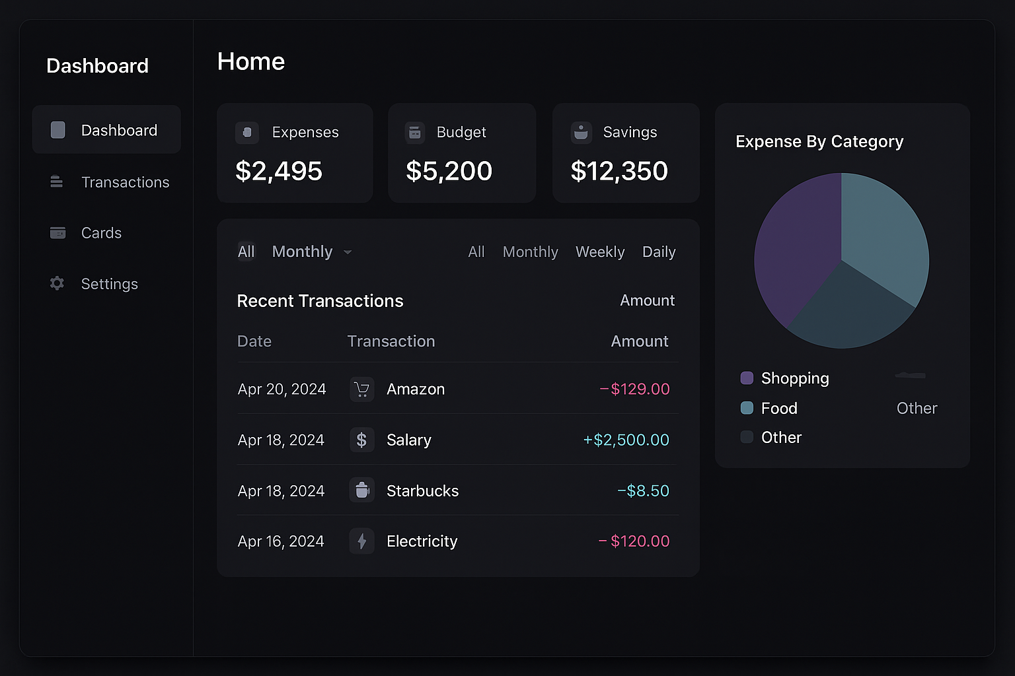

Web app home dashboard - Dark mode comprehensive dashboard variant 1

Variant 2: Widget Grid Layout  
Organizes information through a flexible widget grid system, allowing users to customize their dashboard view with draggable expense charts and financial metric tiles.

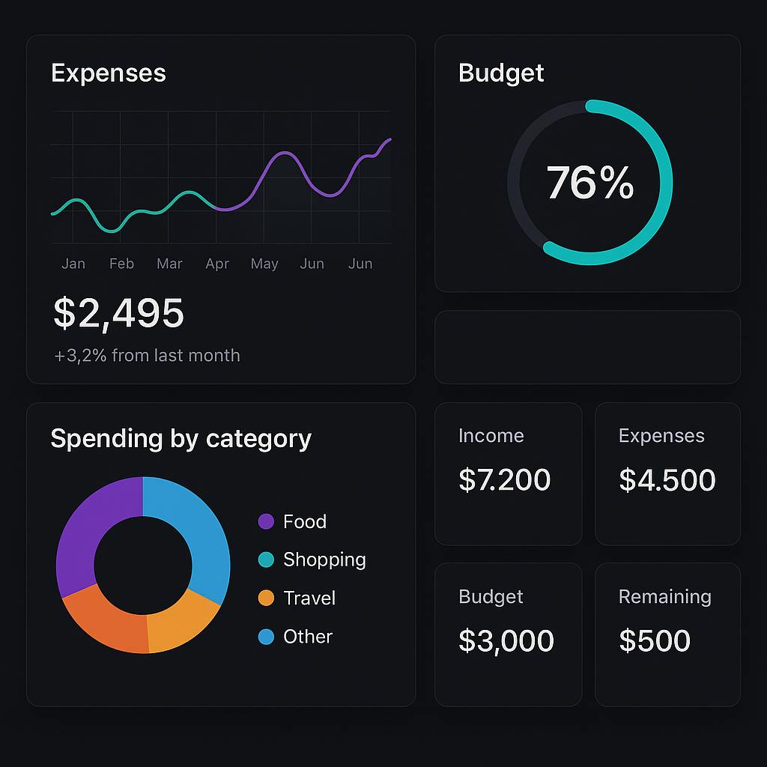

Web app home dashboard - Dark mode widget grid layout variant 2

Variant 3: Minimal Design Approach  
Emphasizes clean, minimal design with large balance displays, simplified spending trends, and streamlined category cards for focused user experience.

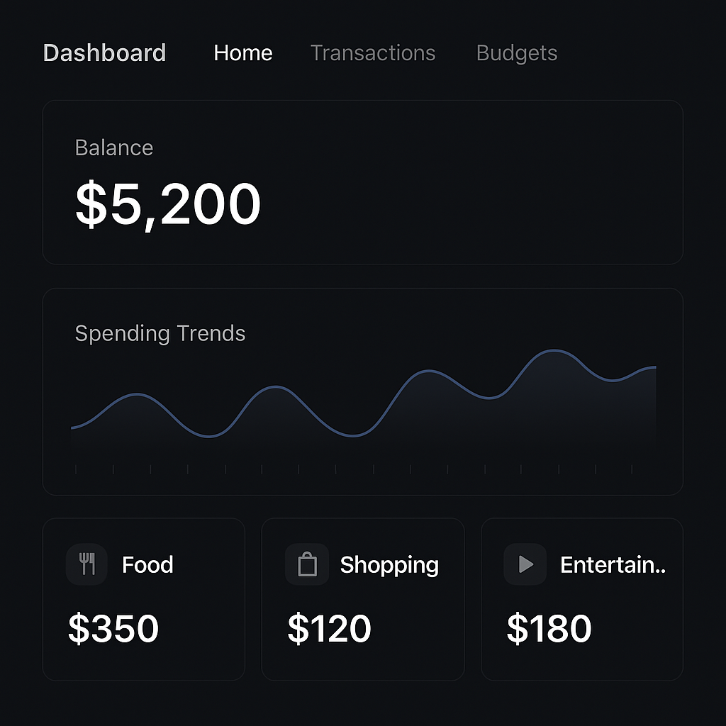

Web app home dashboard - Dark mode minimal design variant 3

## Category Management

The web-based category management system provides advanced organizational tools for managing complex hierarchical category structures.

Variant 1: Hierarchical Tree View  
Displays categories in a traditional tree structure with expand/collapse functionality, supporting deep category nesting and clear parent-child relationships.

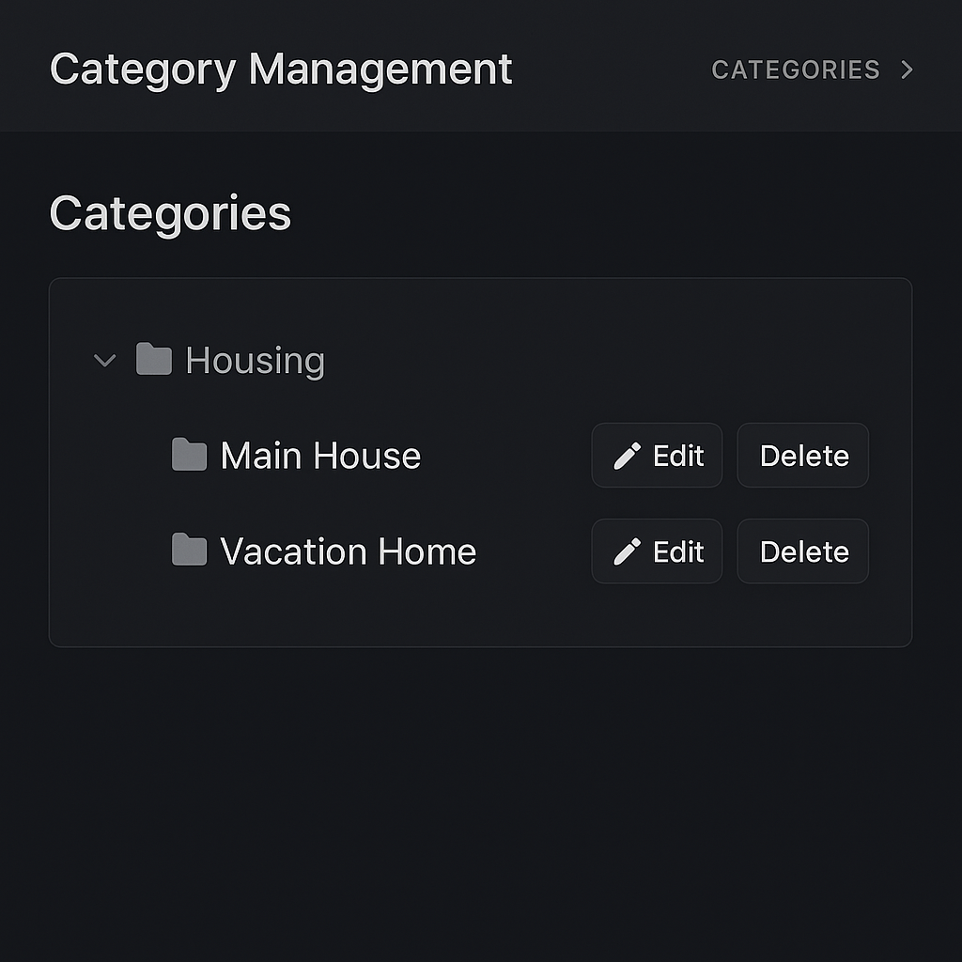

Web app category management - Dark mode hierarchical tree view variant 1

Variant 2: Card Grid Layout  
Presents categories as interactive cards with drag-and-drop functionality, icon customization, and inline editing capabilities for efficient category management.

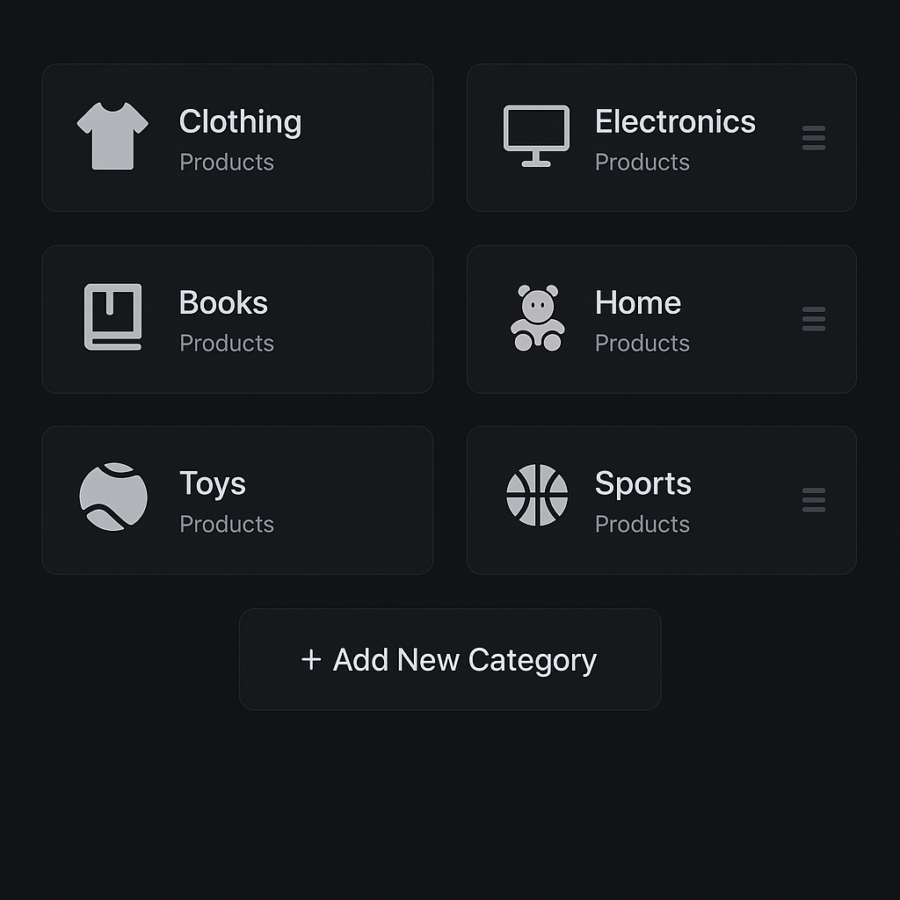

Web app category management - Dark mode card grid layout variant 2

## Budget Tracking and Reports

Web-based budget tracking provides enhanced analytical capabilities with larger charts, detailed filtering options, and comprehensive reporting tools. The interface includes time-based filtering (weekly, monthly, yearly), category-specific budget analysis, and exportable financial reports. Progressive web app features ensure consistent functionality across desktop and mobile browsers while maintaining offline capability for core functions.

## Design System Guidelines

## Color Palette and Dark Mode Implementation

The application utilizes a carefully crafted dark mode color scheme that reduces eye strain while maintaining excellent readability and visual hierarchy. Primary colors include deep backgrounds (#121212, #1e1e1e) with accent colors for interactive elements and data visualization. The color system ensures WCAG 2.1 AA compliance for accessibility.

## Typography and Iconography

Typography follows modern sans-serif principles with clear hierarchy through font weights and sizes. Icon systems utilize consistent stroke weights and styles, with category-specific iconography that enhances user recognition and navigation efficiency.

## Interactive Elements and Feedback

All interactive elements provide immediate visual feedback through hover states, active states, and loading indicators. Button designs emphasize touch-friendly sizing for mobile interfaces while maintaining elegance in desktop environments.

## Technical Implementation Notes

The mock-ups are designed to support the technical architecture outlined in the requirements specification, including:

* React Native compatibility for cross-platform mobile development
* Progressive Web App features for browser-based access
* Offline-first design principles with local data caching
* Google Drive integration points for data synchronization
* Responsive design patterns for multiple screen sizes

## Sample Data Integration

All mock-ups incorporate realistic sample data to demonstrate functionality:

* Expense categories: Housing (Main House/Vacation Home), Transportation, Food & Dining, Healthcare, Entertainment
* Financial data: Monthly budgets, spending totals, category breakdowns, transaction histories
* Time periods: Current month, weekly views, yearly trends
* Progress indicators: Budget vs. actual spending, savings goals, category limits

This comprehensive UI mock-up collection provides a complete visual foundation for the ConsciousBudget application development, ensuring consistent user experience across all platforms while supporting the application's core functionality of manual expense tracking, budget management, and financial reporting.